Department of Computer Science and Engineering (Data Science)
CSDS-A | Batch A2 (CSE - Data Science, Section A)
Attendance Magic: A Smart Geo-Fenced Attendance System with Live Challenge Verification
(Attendance Magic)
S.No. | Student name | Roll / hall ticket no.
1 | A.GREESHMA | 23K91A6706
2 | B.VINAY | 23K91A6740
3 | G.SRIRAM | 23K91A6757
4 | B.SAI KUMAR | 24K95A6704
Under the guidance of: [GUIDE NAME], [DESIGNATION]
DESIGN AND IMPLEMENTATION
This document describes the design of Attendance Magic and how it was implemented: the architecture, the modules, the database schema, the API, key code walkthroughs, and the reasoning behind the main implementation decisions.

1 System Architecture
Attendance Magic has a layered architecture in which the rules live in one place. The principle is that the HTTP layer and both user interfaces contain no verification logic: they call the core/ package, which can also be driven from scripts and unit tests.
The architecture has four layers. Users work in a browser: the faculty member on a laptop and the student on a phone. The original Streamlit interface (port 8501) is kept and uses the same core services. The React front end (port 5102) provides twelve routes, the camera and location capture (getUserMedia or file upload, and the Geolocation API), the Leaflet map and the Recharts charts; its data layer sends the device identifier in the X-Device-Id header and the JWT as a bearer token. The Vite development server forwards /api to the back end, so phones need only one address.
The FastAPI back end (port 8102) is deliberately thin: its 27 endpoints translate HTTP to calls into the core/ package and keep the per-student check-in wizard state on the server. core/ holds all rules: authentication, device fingerprint, geo-fence, liveness, face matching, eligibility and the pipeline, and Excel export. Storage is a local SQLite database with five tables, and the two pre-trained models, MediaPipe Face Mesh and InsightFace buffalo_l, run on the CPU in the same process.
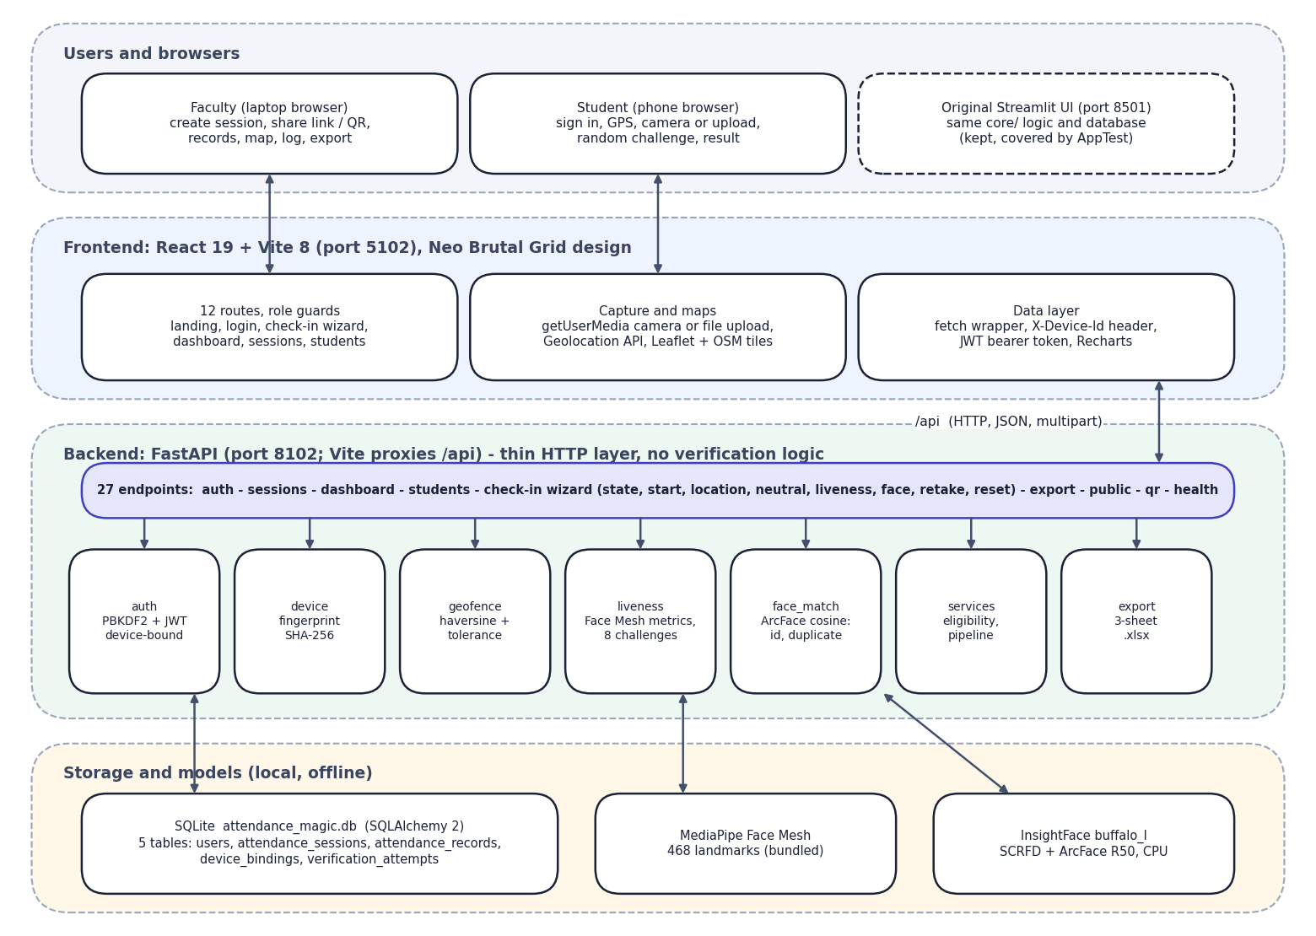
Fig. 1: System architecture of Attendance Magic

2 Module Design
Table 1: Modules of Attendance Magic
Module | Responsibility | Key functions
config.py | All settings with environment overrides | radius, tolerance, accuracy limit, challenge thresholds, face thresholds, JWT, device limit
core/auth.py | Passwords and tokens | hash_password, verify_password, issue_token, verify_token (device claim)
core/device.py | Device identification | fingerprint (SHA-256 of user-agent, language, client hints and X-Device-Id), label
core/geofence.py | Presence by location | haversine_m, check_geofence
core/liveness.py | Random challenge | random_challenge, metrics_from_landmarks, analyze, check_neutral, verify_challenge, decode_image
core/face_match.py | Face identity | embed, cosine, verify_faces (consistency, identity, duplicate)
core/services.py | Business logic | register_user, authenticate, create_session, check_eligibility, record_attendance, run_pipeline, roll_allowed
core/export.py | Excel report | records_dataframe, to_excel_bytes (Summary, Attendance, Verification Log)
backend/api.py | HTTP layer | 27 endpoints, auth dependencies, check-in wizard state, QR generation
frontend/src | React application | 12 pages, UI components, camera and location components, API client

3 Database Design
The schema is defined with SQLAlchemy 2 in core/models.py and created on first start (init_db). Timestamps are stored in UTC and displayed in the configured time zone (Asia/Kolkata by default). The tables and their columns are:
Table 2: Database tables
Table | Columns | Keys and constraints
users | id, role ('faculty' or 'student'), username, full_name, roll_number, password_hash, face_embedding (512 x float32, 2,048 bytes), created_at | PK id; username unique; roll_number unique
attendance_sessions | id, token, faculty_id, course_code, course_name, section, starts_at, ends_at, latitude, longitude, radius_m, allowed_rolls, is_closed, created_at | PK id; token unique and indexed; FK faculty_id -> users
attendance_records | id, session_id, student_id, roll_number, student_name, marked_at, latitude, longitude, gps_accuracy_m, distance_m, device_hash, challenge, liveness_score, identity_similarity, max_duplicate_similarity, face_embedding | PK id; FKs to sessions and users; UNIQUE(session_id, student_id)
device_bindings | id, user_id, device_hash, device_label, first_seen, last_seen | PK id; FK user_id; UNIQUE(user_id, device_hash)
verification_attempts | id, session_id, roll_number, stage (eligibility, location, liveness, face, success), passed, reason, device_hash, created_at | PK id; FK session_id

The database has five tables. users holds faculty and students (the student's reference embedding is a 512-float binary column). attendance_sessions belongs to a faculty user through faculty_id and holds the window, the geo-fence and the allowed roll patterns. attendance_records links a session and a student and stores the evidence of the check-in (distance, accuracy, challenge, liveness score, identity and duplicate similarities, device hash and the face embedding); a unique constraint on (session_id, student_id) makes a second record impossible. device_bindings stores the devices a student has used, unique per user and device. verification_attempts is the audit log, one row per stage attempt.

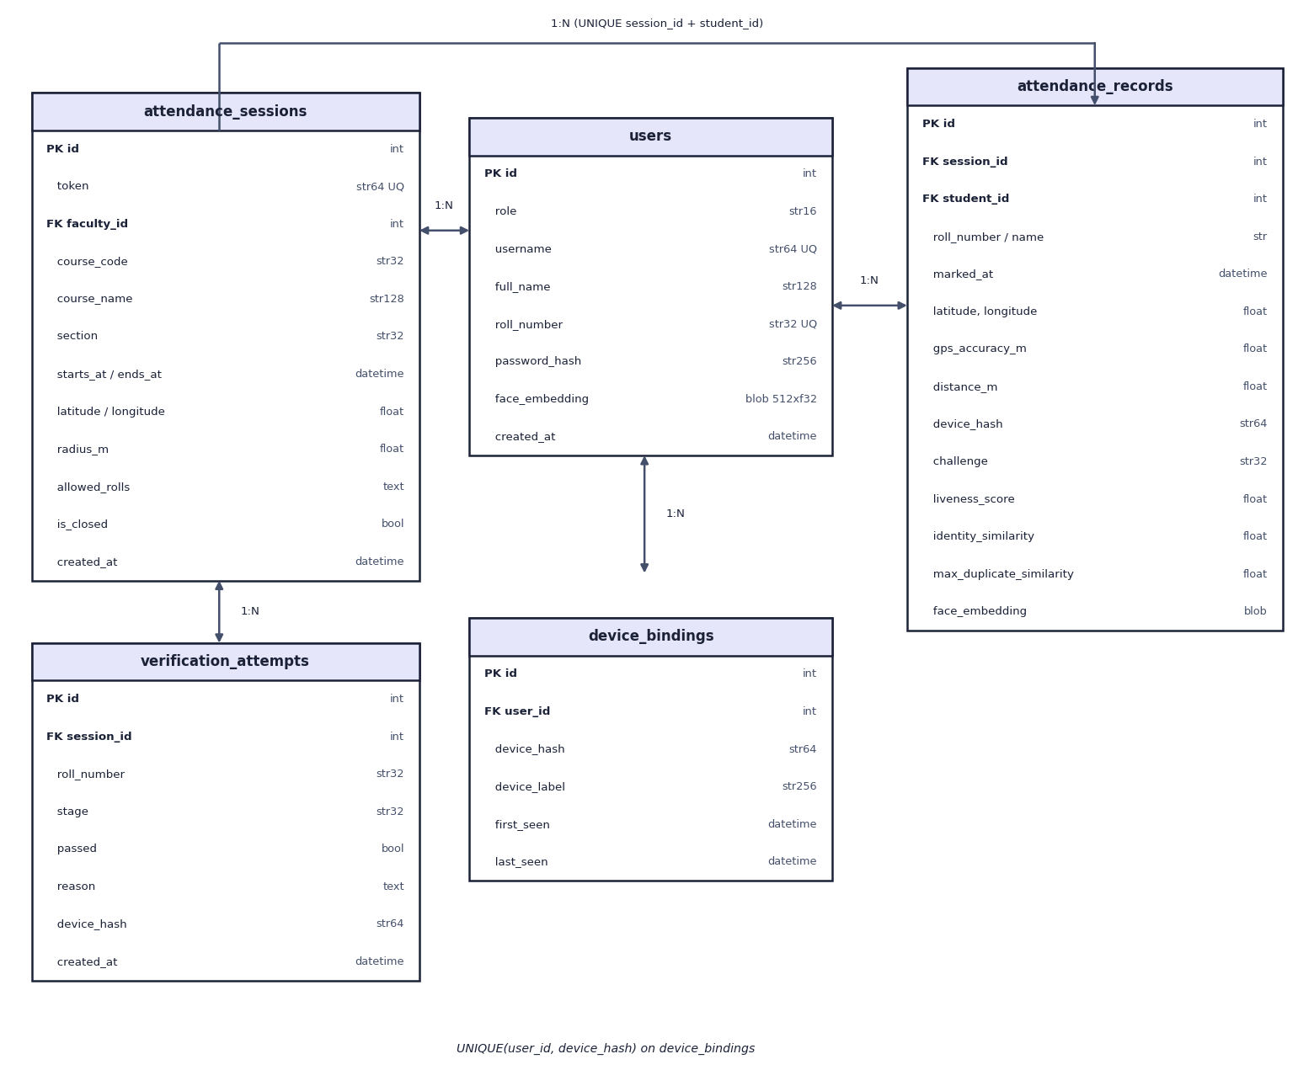
Fig. 2: Entity-relationship diagram of the Attendance Magic database (5 tables)

Design notes. The embedding is stored as raw float32 bytes (ndarray.tobytes) and read back with np.frombuffer, which is compact and exact. The record repeats the student's roll number and name so that an export stays correct if an account changes. The attempts table is append-only and carries no foreign key to users because attempts may involve roll numbers that do not exist as accounts.

4 Application Architecture
The back end is a FastAPI application (backend/api.py). At start-up it creates the tables and loads the two models in a background thread, so the first request after start-up does not pay the model-loading time (0.8 s and 1.5 s measured). Every protected endpoint declares a dependency that verifies the bearer token against the device hash recomputed from the request (current_claims), and a second dependency that enforces the role (faculty_claims or student_claims).
Check-in wizard state. A student's progress is kept in a server-side dictionary keyed by (user, session, device): the step, the current random challenge, the number of failed liveness tries, the GPS fix, the distance, the liveness score and, between the liveness and face steps, the two photographs as bytes. The photographs are dropped from the state after a successful record, the whole state on reset and on sign-out, and the photographs are never written to disk. The React page reads the state from /state when it loads, so a refresh returns the student to the same step.
Front end. React 19 with React Router 7; each page is a lazy-loaded chunk (the production build splits 20 chunks, the largest 581 kB or 194 kB gzipped). A small fetch wrapper adds the device id and the token and turns error responses into readable messages. The camera component calls getUserMedia, mirrors the captured frame to match camera_mirrored, and every photo slot has an upload tab for testing without a camera. Maps use Leaflet with OpenStreetMap tiles.

5 API Design
All endpoints are under /api, accept and return JSON (photos as multipart form data) and are documented automatically at /docs (Figure in Appendix C). Errors use HTTP status codes with a detail message that the UI shows to the user: 400 invalid input, 401 not signed in or token problem, 403 wrong role, 404 not found, 409 wizard step out of order.
Table 3: REST API of Attendance Magic (27 endpoints)
Method and path | Role | Purpose
GET /api/health, /api/config, /api/models, /api/stats | public | status, public settings and thresholds, loaded models, landing-page totals
GET /api/qr?text= | public | QR code PNG for a link
POST /api/auth/register | public | create a faculty or student account (student: reference face required, checked for a frontal single face)
POST /api/auth/login, /logout; GET /api/auth/me | any | sign in (JWT bound to the device), sign out, current user and device
GET, POST /api/sessions; GET /api/sessions/{id} | faculty | list own sessions, create a session, detail with records, rows and attempts
POST /api/sessions/{id}/close; GET .../export | faculty | close a session; download the Excel report
GET /api/dashboard | faculty | aggregates: totals, per-session rows, checks by stage, latest attempts
GET /api/students; POST /api/students/{id}/reset-devices, /enroll | faculty | list students, remove device bindings, replace a reference face
GET /api/public/sessions/{token} | public | session header for the check-in page
GET /api/checkin/{token}/state; POST .../start, /location, /neutral, /liveness, /face, /retake, /reset | student | the check-in wizard (eligibility, location, neutral-frame check, challenge, face verification, retake, start over)

6 Key Code Walkthroughs

6.1 Geo-fence check
check_geofence rejects a fix whose reported accuracy is worse than the limit, then compares the haversine distance with the radius plus the tolerance. The returned object carries the distance, the allowed distance and a sentence for the student.
Listing: core/geofence.py: check_geofence
def check_geofence(
student_lat: float,
student_lon: float,
center_lat: float,
center_lon: float,
radius_m: float,
accuracy_m: float | None = None,
) -> GeoResult:
"""
Verify a student's GPS position against the session boundary.

The allowed distance is radius + a small fixed tolerance for GPS noise.
Readings with very poor accuracy are rejected outright.
"""
if accuracy_m is not None and accuracy_m > config.MAX_GPS_ACCURACY_M:
return GeoResult(
False,
haversine_m(student_lat, student_lon, center_lat, center_lon),
radius_m,
f"GPS accuracy too low (±{accuracy_m:.0f} m). Move to an open area and retry.",
)

distance = haversine_m(student_lat, student_lon, center_lat, center_lon)
allowed = radius_m + config.GEOFENCE_TOLERANCE_M
if distance <= allowed:
return GeoResult(True, distance, allowed, f"Inside geo-fence ({distance:.1f} m from centre).")
return GeoResult(
False,
distance,
allowed,
f"Outside geo-fence: you are {distance:.0f} m away, limit is {allowed:.0f} m.",
)

6.2 Liveness: landmark metrics and challenge decision
Listing: core/liveness.py: metrics_from_landmarks
def metrics_from_landmarks(pts: np.ndarray, n_faces: int = 1) -> FaceMetrics:
"""
Compute pose/expression metrics from an (N, 2) array of normalised landmark
coordinates (x, y in 0..1). Pure numpy so it is unit-testable without MediaPipe.
"""
nose, chin = pts[NOSE_TIP], pts[CHIN]
fl, fr = pts[FACE_LEFT], pts[FACE_RIGHT]
x_left, x_right = min(fl[0], fr[0]), max(fl[0], fr[0])
yaw = (nose[0] - x_left) / max(x_right - x_left, 1e-6) - 0.5

l_eye_c = (pts[L_EYE_OUTER] + pts[L_EYE_INNER]) / 2
r_eye_c = (pts[R_EYE_OUTER] + pts[R_EYE_INNER]) / 2
eyes_mid = (l_eye_c + r_eye_c) / 2
pitch = (nose[1] - eyes_mid[1]) / max(chin[1] - eyes_mid[1], 1e-6)

# image-left eye -> image-right eye angle
left_eye, right_eye = (l_eye_c, r_eye_c) if l_eye_c[0] < r_eye_c[0] else (r_eye_c, l_eye_c)
roll_deg = math.degrees(math.atan2(right_eye[1] - left_eye[1], right_eye[0] - left_eye[0]))

mar = _dist(pts[LIP_TOP], pts[LIP_BOTTOM]) / max(_dist(pts[MOUTH_LEFT], pts[MOUTH_RIGHT]), 1e-6)

ear_l = _dist(pts[L_EYE_TOP], pts[L_EYE_BOTTOM]) / max(_dist(pts[L_EYE_OUTER], pts[L_EYE_INNER]), 1e-6)
ear_r = _dist(pts[R_EYE_TOP], pts[R_EYE_BOTTOM]) / max(_dist(pts[R_EYE_OUTER], pts[R_EYE_INNER]), 1e-6)
ear = (ear_l + ear_r) / 2

return FaceMetrics(n_faces=n_faces, yaw=float(yaw), pitch=float(pitch), roll_deg=float(roll_deg),
mar=float(mar), ear=float(ear))

Listing: core/liveness.py: verify_challenge
def verify_challenge(challenge: str, neutral: FaceMetrics, chal: FaceMetrics) -> LivenessResult:
"""Compare the challenge frame against the neutral frame for the requested action."""
if err := check_neutral(neutral):
return LivenessResult(False, 0.0, f"Neutral photo problem: {err}", neutral, chal)
if chal.n_faces == 0:
return LivenessResult(False, 0.0, "No face detected in the challenge photo.", neutral, chal)
if chal.n_faces > 1:
return LivenessResult(False, 0.0, "More than one face in the challenge photo.", neutral, chal)

# In a mirrored (selfie) image the student's left is the image's left, so a
# LEFT turn moves the nose to smaller x (negative yaw). Non-mirrored flips it.
direction = -1.0 if config.CAMERA_MIRRORED else 1.0

d_yaw = chal.yaw - neutral.yaw
d_pitch = chal.pitch - neutral.pitch
d_roll = chal.roll_deg - neutral.roll_deg

def result(measured: float, threshold: float, label: str) -> LivenessResult:
measured = float(measured)
score = max(0.0, min(1.0, measured / threshold)) if threshold > 0 else 0.0
passed = bool(measured >= threshold)
reason = (f"{label}: measured {measured:.3f}, required {threshold:.3f} — "
+ ("PASS" if passed else "not enough movement, try a bigger motion"))
return LivenessResult(passed, round(score, 3), reason, neutral, chal)

if challenge == "TURN_LEFT":
return result(direction * d_yaw, config.LIVENESS_YAW_DELTA, "Head turn left")
if challenge == "TURN_RIGHT":
return result(-direction * d_yaw, config.LIVENESS_YAW_DELTA, "Head turn right")
if challenge == "LOOK_UP":
return result(-d_pitch, config.LIVENESS_PITCH_DELTA, "Look up")
if challenge == "LOOK_DOWN":
return result(d_pitch, config.LIVENESS_PITCH_DELTA, "Look down")
if challenge == "TILT_LEFT":
return result(direction * d_roll, config.LIVENESS_ROLL_DEG, "Tilt left")
if challenge == "TILT_RIGHT":
return result(-direction * d_roll, config.LIVENESS_ROLL_DEG, "Tilt right")
if challenge == "OPEN_MOUTH":
return result(chal.mar, config.LIVENESS_MOUTH_OPEN_MAR, "Mouth open ratio")
if challenge == "CLOSE_EYES":
# Lower EAR = more closed. Score by how far below the threshold we are.
measured = config.LIVENESS_EYES_CLOSED_EAR - chal.ear + config.LIVENESS_EYES_CLOSED_EAR
r = result(measured, config.LIVENESS_EYES_CLOSED_EAR, "Eyes closed")
r.reason = (f"Eyes closed: eye-aspect-ratio {chal.ear:.3f}, must be below "
f"{config.LIVENESS_EYES_CLOSED_EAR:.3f} — " + ("PASS" if r.passed else "eyes still open"))
return r
return LivenessResult(False, 0.0, f"Unknown challenge {challenge}", neutral, chal)

6.3 Face decision
Listing: core/face_match.py: verify_faces
def verify_faces(
live_embedding: np.ndarray,
enrolled_embedding: np.ndarray | None,
session_embeddings: list[tuple[str, np.ndarray]],
second_frame_embedding: np.ndarray | None = None,
) -> MatchResult:
"""
1. Both captured frames must be the same person (no swapping people mid-check).
2. Live face must match the enrolled reference face (identity).
3. Live face must NOT match any face already recorded in this session under
another roll number (duplicate / proxy check).
"""
consistency = None
if second_frame_embedding is not None:
consistency = cosine(live_embedding, second_frame_embedding)
if consistency < config.FRAME_CONSISTENCY_THRESHOLD:
return MatchResult(
False,
f"The two photos appear to be different people (similarity {consistency:.2f}).",
frame_consistency=consistency,
)

identity = None
if enrolled_embedding is not None:
identity = cosine(live_embedding, enrolled_embedding)
if identity < config.IDENTITY_THRESHOLD:
return MatchResult(
False,
f"Face does not match the enrolled reference face for this roll number "
f"(similarity {identity:.2f}, required ≥ {config.IDENTITY_THRESHOLD:.2f}).",
identity_similarity=identity,
frame_consistency=consistency,
)
elif config.REQUIRE_ENROLLMENT:
return MatchResult(False, "No enrolled reference face. Please enrol your face first.",
frame_consistency=consistency)

max_dup, dup_of = 0.0, None
for roll, emb in session_embeddings:
s = cosine(live_embedding, emb)
if s > max_dup:
max_dup, dup_of = s, roll
if dup_of is not None and max_dup >= config.DUPLICATE_THRESHOLD:
return MatchResult(
False,
f"This face has already marked attendance in this session as {dup_of} "
f"(similarity {max_dup:.2f}). Proxy attendance blocked.",
identity_similarity=identity,
max_duplicate_similarity=max_dup,
duplicate_of=dup_of,
frame_consistency=consistency,
)

return MatchResult(
True,
"Face verified: identity matched and no duplicate in this session.",
identity_similarity=identity,
max_duplicate_similarity=max_dup if session_embeddings else None,
frame_consistency=consistency,
)

6.4 Eligibility and the pipeline
Listing: core/services.py: check_eligibility
def check_eligibility(session: AttendanceSession, user: User, device_hash: str,
device_label: str = "", now: datetime | None = None) -> Eligibility:
"""Session window, roll-number restriction, duplicate record, device binding."""
now = now or utcnow()
status = session.status(now)
if status != "live":
msgs = {"upcoming": "This session has not started yet.",
"expired": "This session has expired.",
"closed": "This session was closed by the faculty."}
return Eligibility(False, msgs[status])
if user.role != "student" or not user.roll_number:
return Eligibility(False, "Only student accounts can mark attendance.")
if not roll_allowed(session.allowed_rolls, user.roll_number):
return Eligibility(False, f"Roll number {user.roll_number} is not allowed in this session.")

with get_session() as db:
already = db.scalar(select(AttendanceRecord).where(
AttendanceRecord.session_id == session.id, AttendanceRecord.student_id == user.id))
if already:
return Eligibility(False, "Attendance already marked for this session.")

# One device may mark only one roll number per session.
other = db.scalar(select(AttendanceRecord).where(
AttendanceRecord.session_id == session.id, AttendanceRecord.device_hash == device_hash,
AttendanceRecord.student_id != user.id))
if other:
return Eligibility(False, f"This device already marked attendance for {other.roll_number} in this session.")

# Device binding: a student may use at most MAX_DEVICES_PER_STUDENT devices.
bindings = list(db.scalars(select(DeviceBinding).where(DeviceBinding.user_id == user.id)))
known = next((b for b in bindings if b.device_hash == device_hash), None)
if known:
known.last_seen = now
elif len(bindings) >= config.MAX_DEVICES_PER_STUDENT:
return Eligibility(False, "This device is not registered to your account. "
"Use your usual device or ask faculty to reset your devices.")
else:
db.add(DeviceBinding(user_id=user.id, device_hash=device_hash, device_label=device_label))
return Eligibility(True, "Eligible.")

Listing: core/services.py: run_pipeline
def run_pipeline(session: AttendanceSession, user: User, device_hash: str, lat: float, lon: float,
accuracy: float | None, challenge: str, neutral_bgr: np.ndarray,
challenge_bgr: np.ndarray, now: datetime | None = None) -> PipelineResult:
"""Run every check in order exactly as the UI does, logging each stage."""
roll = user.roll_number or user.username

elig = check_eligibility(session, user, device_hash, now=now)
log_attempt(session.id, roll, "eligibility", elig.ok, elig.reason, device_hash)
if not elig.ok:
return PipelineResult(False, "eligibility", elig.reason)

geo = geofence.check_geofence(lat, lon, session.latitude, session.longitude, session.radius_m, accuracy)
log_attempt(session.id, roll, "location", geo.inside, geo.reason, device_hash)
if not geo.inside:
return PipelineResult(False, "location", geo.reason)

live = liveness.verify_challenge(challenge, liveness.analyze(neutral_bgr), liveness.analyze(challenge_bgr))
log_attempt(session.id, roll, "liveness", live.passed, live.reason, device_hash)
if not live.passed:
return PipelineResult(False, "liveness", live.reason)

try:
emb_neutral = face_match.embed(neutral_bgr)
emb_chal = face_match.embed(challenge_bgr)
except face_match.FaceError as exc:
log_attempt(session.id, roll, "face", False, str(exc), device_hash)
return PipelineResult(False, "face", str(exc))

enrolled = face_match.from_bytes(user.face_embedding) if user.face_embedding else None
match = face_match.verify_faces(emb_neutral, enrolled, session_embeddings(session.id, user.id), emb_chal)
log_attempt(session.id, roll, "face", match.passed, match.reason, device_hash)
if not match.passed:
return PipelineResult(False, "face", match.reason)

rec = record_attendance(session, user, lat=lat, lon=lon, accuracy=accuracy, distance=geo.distance_m,
device_hash=device_hash, challenge=challenge, liveness_score=live.score,
identity_sim=match.identity_similarity, dup_sim=match.max_duplicate_similarity,
embedding=emb_neutral)
return PipelineResult(True, "success", "Attendance recorded.", rec)

7 Implementation Decisions and their Reasoning
Table 4: Implementation decisions
Decision | Alternatives considered | Reasoning
Pre-trained models, no training | Train a recogniser per class (as the base paper does) | ArcFace embeddings need one reference photo and no retraining; training data would have to be collected and protected
Random active challenge for liveness | Passive anti-spoofing model; blink detection | No extra model; works on any camera; transparent thresholds; cannot be prepared in advance. Its weakness against rotated and multiple photos was then measured
Two still photographs instead of video | Continuous video capture | Works with a browser file upload and a phone camera alike; small payload; simple server logic
Thin FastAPI layer over core/ | Rules inside the HTTP handlers | One implementation shared with the Streamlit UI and with scripts and tests
Wizard state on the server | State in the browser | Steps cannot be skipped (409); the random challenge and photos never leave the server's control
JWT with a device claim | Cookie sessions | Stateless API for phones; a stolen token fails on another device
Device hash from headers plus X-Device-Id | Cookies only | Stable across requests; combined with a per-browser identifier
Embeddings stored, photographs not | Store photographs | Smaller, less sensitive data; the duplicate scan needs only vectors
Haversine, tolerance and accuracy gate | Vincenty; no tolerance | 0.47% error is negligible against GPS noise; tolerance and gate absorb poor fixes
Conservative thresholds (0.40 and 0.45) | Equal-error threshold (0.19) | Margin against look-alikes; measured cost 1.3-2.9% retakes or missed duplicates
SQLite | PostgreSQL (the abstract mentioned Supabase) | Zero setup for one college; adequate for the measured load; PostgreSQL is available by DATABASE_URL
FastAPI and React | Django REST Framework (the abstract), Streamlit only | Typed models and automatic docs; a responsive phone-first interface; Streamlit kept as the original UI
Public benchmark and attack experiments | Only demo runs | Gives numbers that can be reproduced and exposes the weak points

8 Security and Error Handling
Table 5: Security controls
Threat | Control | Evidence
Password disclosure | PBKDF2-HMAC-SHA256, 200,000 iterations, 16-byte random salt; constant-time comparison | test_password_hash_roundtrip
Token theft | JWT HS256 with 120-minute expiry and a device claim checked on every request | test_jwt_bound_to_device; smoke test: token from another device -> 401
Privilege misuse | Role dependencies; session ownership check (404 for another faculty's session) | smoke test: student on faculty API -> 403; faculty check-in -> 403
Forwarded link | Link grants only a sign-in page; every check still applies | demo scenarios 3-6
Repeat or proxy marking | UNIQUE(session_id, student_id); device may mark one roll per session; duplicate-face scan | smoke test; demo scenarios 2, 6, 8
Out-of-order calls | Wizard steps enforced on the server (HTTP 409) | api._require_step
Cross-origin abuse | CORS limited to localhost origins | api.py middleware
Bad input | Pydantic models, image decode errors -> 400, face errors -> reasons | api._read_image, FaceError

Known weaknesses. The default AM_JWT_SECRET is a placeholder and PyJWT warns that the 30-byte default is shorter than the recommended 32 bytes; it must be changed for any real use. There is no rate limit or lockout on sign-in, the manual-location tab is enabled by default for testing (AM_ALLOW_MANUAL_LOCATION) and must be disabled in production, and wizard state in memory is lost on restart.

9 User Interface Design
The React interface follows a 'Neo Brutal Grid' design: thick black borders, hard offset shadows, a lime, coral and sky palette on an off-white grid, monospace labels and a light and dark theme. The design goals were legibility on a phone in bright light, large touch targets, and the reason for every outcome shown in words and colour (not colour alone).
- Public pages: landing page with live statistics, how-it-works page, sign-in for each role, registration with reference-face upload, and a page to paste a session link.
- Student check-in: a six-step stepper (Sign in, Eligibility, Location, Live challenge, Face match, Done) with the session header on top; each step shows one task and its error, if any.
- Faculty area: a sidebar (Dashboard, Sessions, New session, Students), KPI tiles, tabs for records, map, log and analytics on a session, and a drawer for managing one student.
- Accessibility: labelled controls, reduced-motion support and text labels next to every status colour.
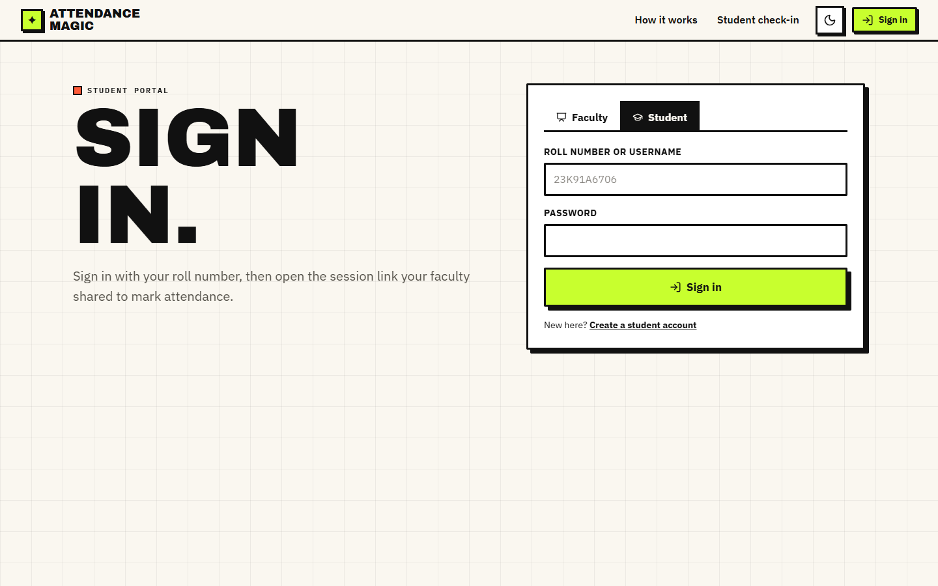
Fig. 3: Student sign-in screen
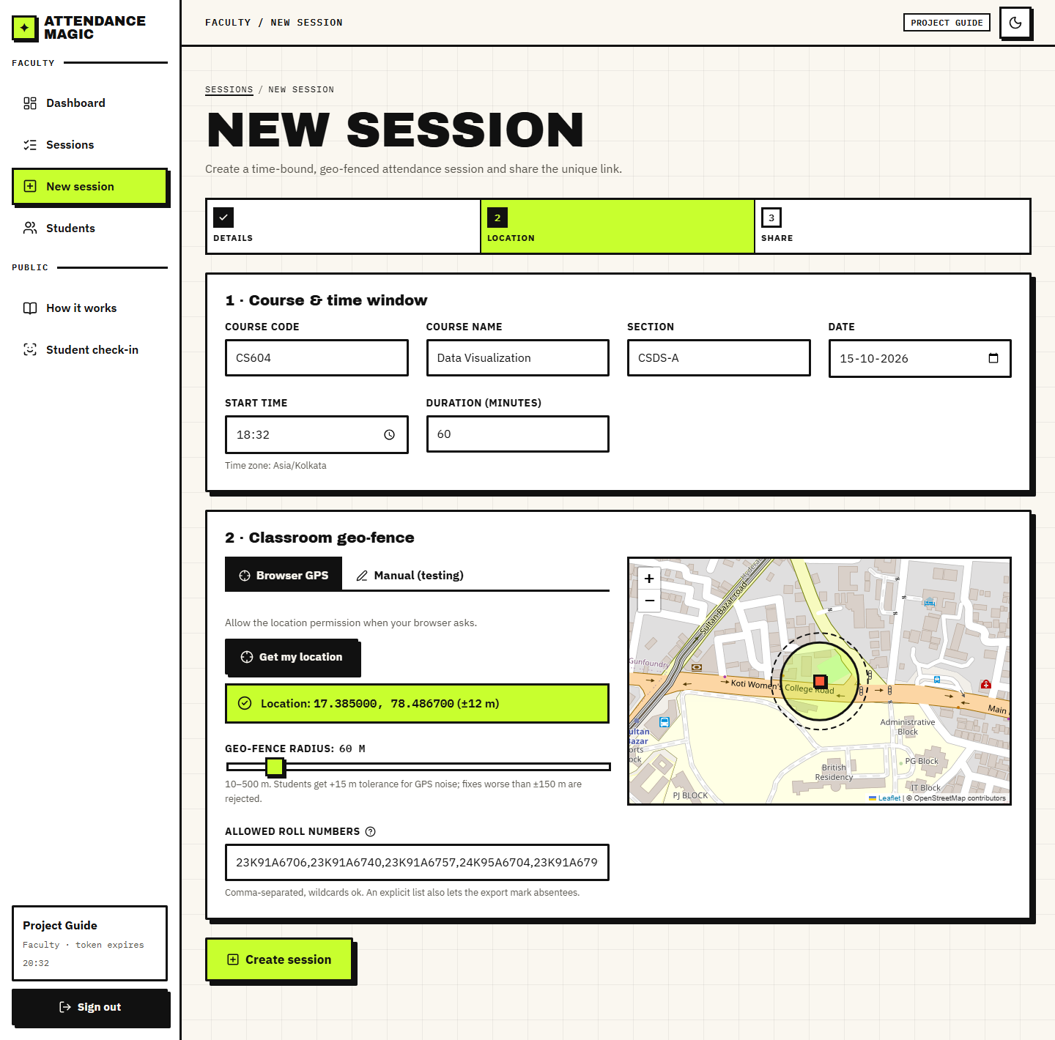
Fig. 4: New-session form with geo-fence preview

10 Installation and Execution
Windows: run setup.bat once (creates a Python 3.11 virtual environment, installs the requirements, seeds the demo accounts and runs npm install) and run.bat every time; it starts the API on port 8102 and the React app on port 5102 and opens the browser. stop.bat stops both. Linux and macOS: pip install -r requirements.txt -r backend/requirements.txt, python scripts/seed_demo.py, uvicorn backend.api:app --port 8102 and npm run dev in frontend/. The original interface starts with streamlit run app.py. Full steps are in Appendix B and in docs/03_HOW_TO_RUN.md.

